**Discussion Question: 100 Things**

Using the ***100 Things Every Designer Should Know About People*** reading assignment, select two (2) of the "things" you read about.  In your post, include the number and title of the "thing" (i.e. #36 Time is Relative)  and then do two embellishments, one embellishment and one visual example, or two visual examples.

1. **Embellish:** Tell us something that the reading did not tell us on that specific "thing" or embellish on what was presented. Be sure you are adding meaningful content to the conversation and not just making noise. Your addition can be a link to an article or you can write out your embellishment.
2. **Visual Example:** Provide us with a graphic example that is relevant to web design. This can be something you create or something you find. Again, be sure to add meaningful content to the conversation.

My first topic of embellishment is topic 46: People Are Worse At Multitasking Than They Think. In this digital age, it can be common to become overstimulated with the amount of electronics like televisions, cell phones, laptops, etc., and the access to applications and websites they provide. It can seem harmless to throw on a show, movie, podcast, audiobook, or whatever it may be while completing a task with the mindset that multitasking is okay. But the reality is the task will take much longer than normal to complete because all the focus is no longer on the desired task.

I included a picture of someone working but multitasking using their cell phone and laptop.



The second topic I decided to embellish is topic 50: People Are More Motivated As They Get Closer To A Goal. The illusion of progress is something that humans need. It helps improve patience with people and is an indicator that even if something may be taking a while, there is at least a notable difference. It is like the feeling of when you get to move forward in a line as it starts to clear up. This could be a loading bar on a download to show the progression of the download. It can feel frustrating when something takes a long time but does not show any progress. A loading bar for an advertisement to show how far along it is. This gives the viewer an idea of how much time is left. Some progress bars may speed up faster at the beginning to show progress, even if it is not accurate.

I included a picture of a Dutch Bros app because you get a free drink when downloading it, but people may not want to return after that. Dutch Bros provided bonus points to get people closer to their goal, which can push someone to go back.

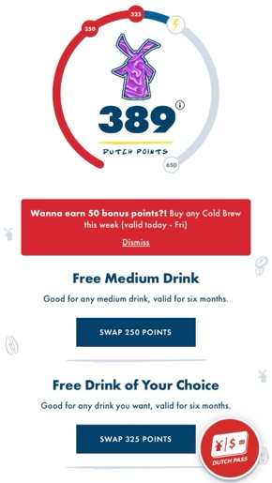

***Before you submit your thread, put your name in the subject line.***

**Assignment Requirements and Grading:**

1. An initial post of approximately 250 words is due by **Thursday, 11:59 p.m., CST**.
2. For the initial post to be considered substantive, it should be at least 250 words in length and fully cover the topics being presented. Single sentence definitions or responses will not be awarded points.
3. Submit your post by clicking on the **Assignment Link** above, then **Create Thread**. You must create a thread in order to view your peers' posts. Tip: Create your post in a Word document and then copy and paste your work into the thread.
4. A minimum of three (3) responses, **to the original threads of other students**, of 100-200 words each are due by **Sunday, 11:59 p.m., CST**.
5. To view the rubric grading criteria, click on the following link: [Discussion Board Grading Rubric](https://content.bellevue.edu/cst/csd/rubricdbv3.pdf).

**(50 points)**